Working with Conditionals

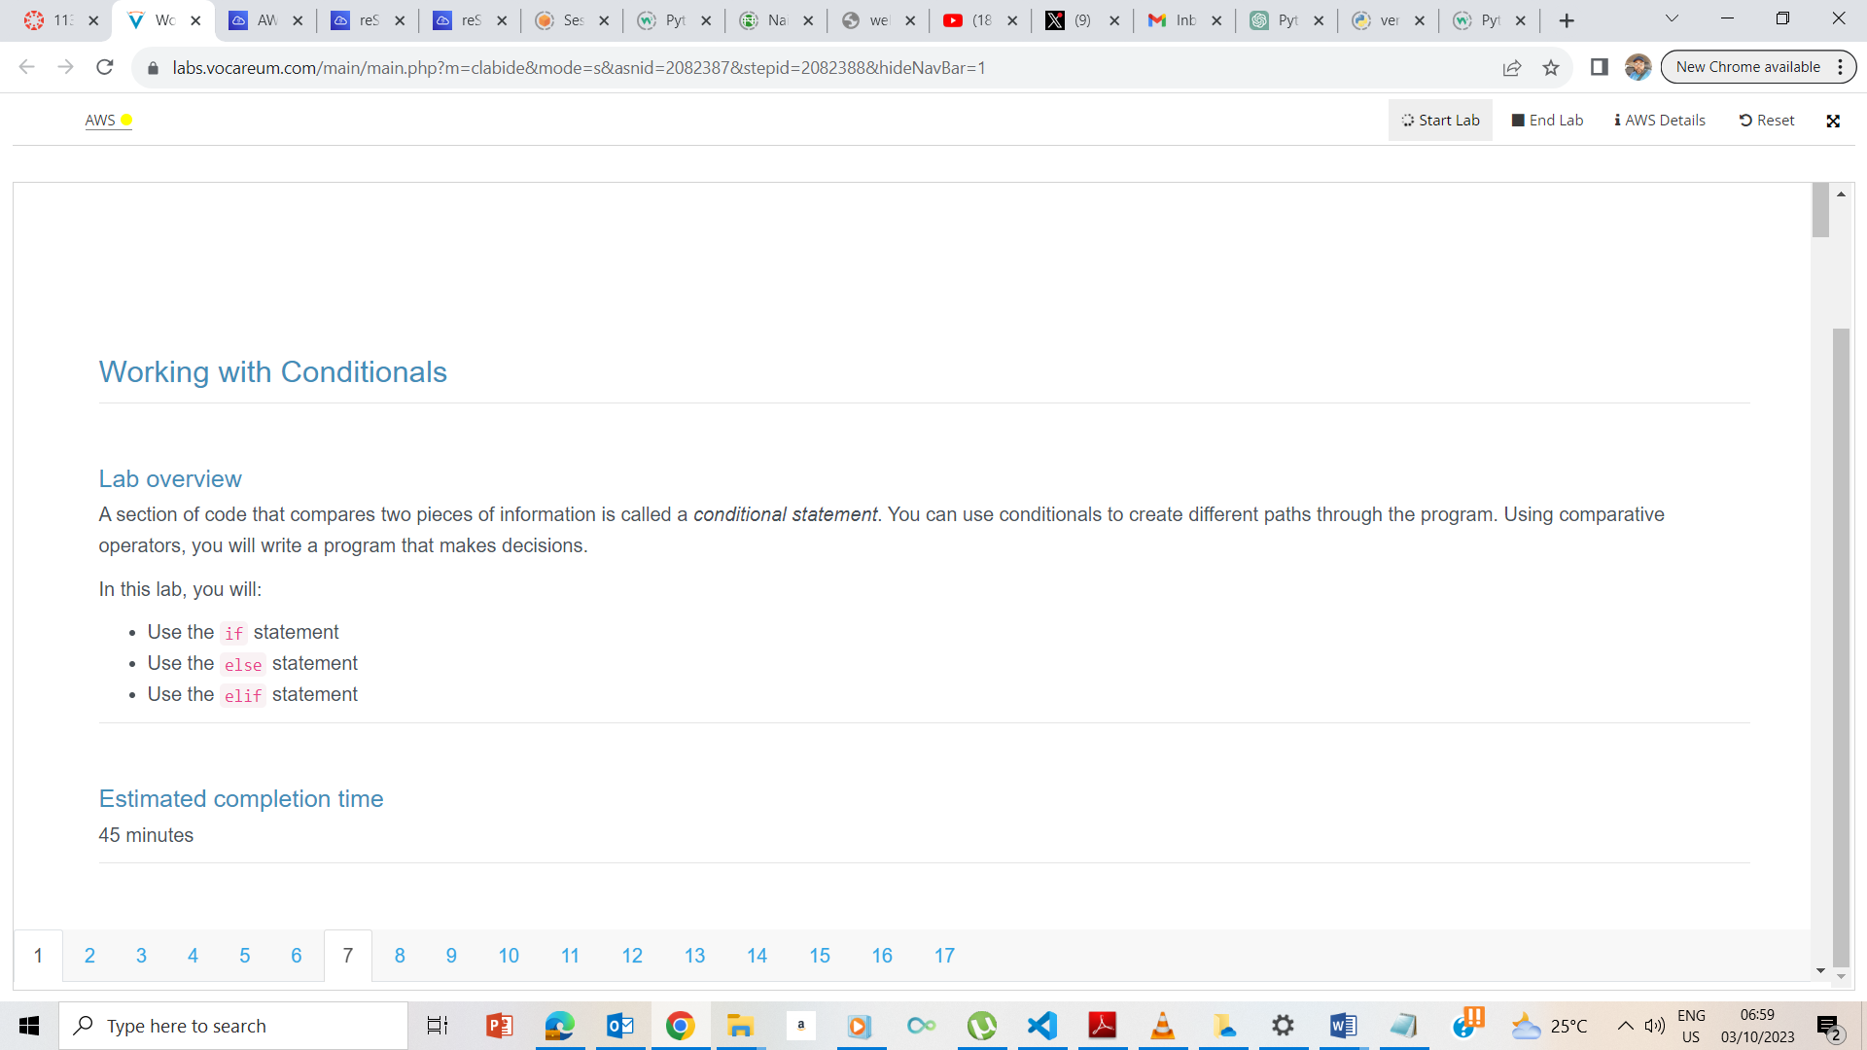

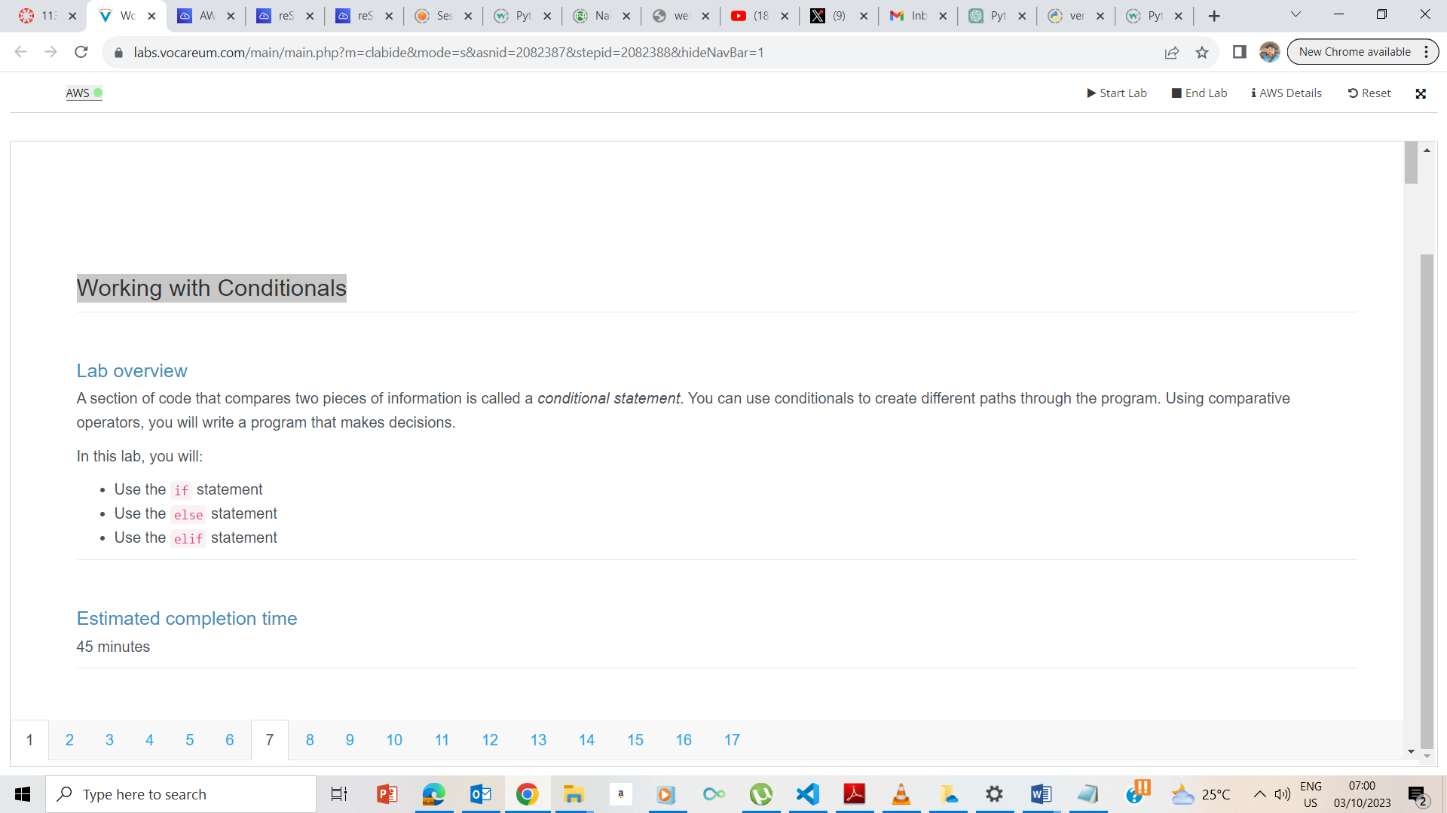

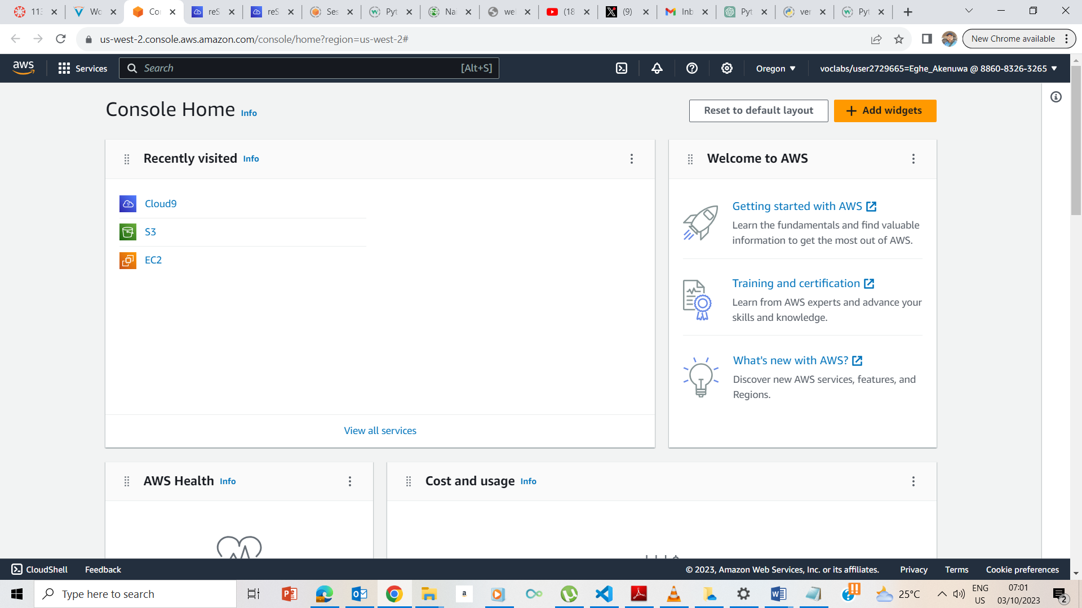

I clicked on Start, waited for the button under AWS Button to turn green, and upon turning reen, I clicked on the AWS button to take me to the AWS Management console. 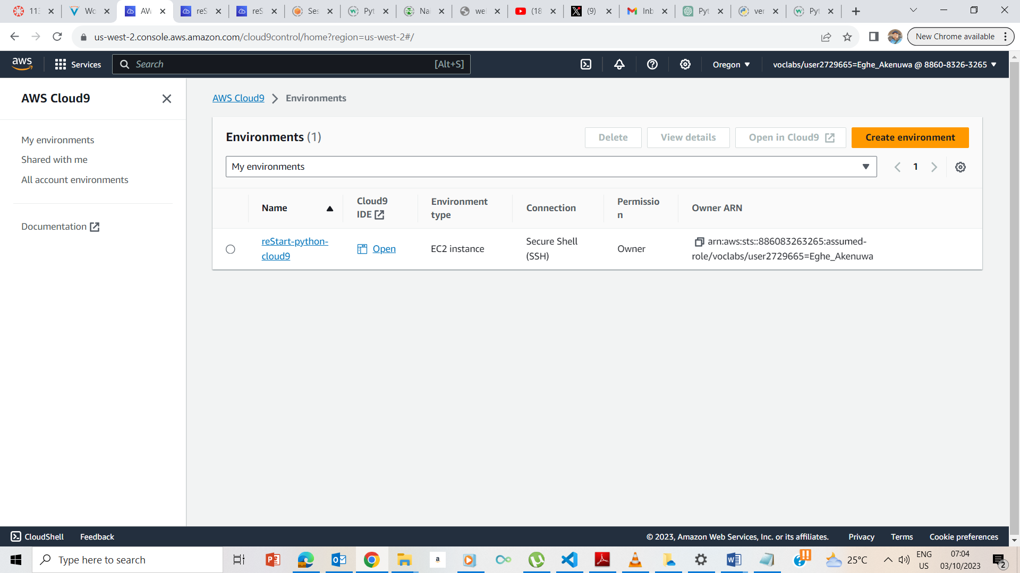

I clicked on the Cloud9 icon to take me to the Cloud9 page

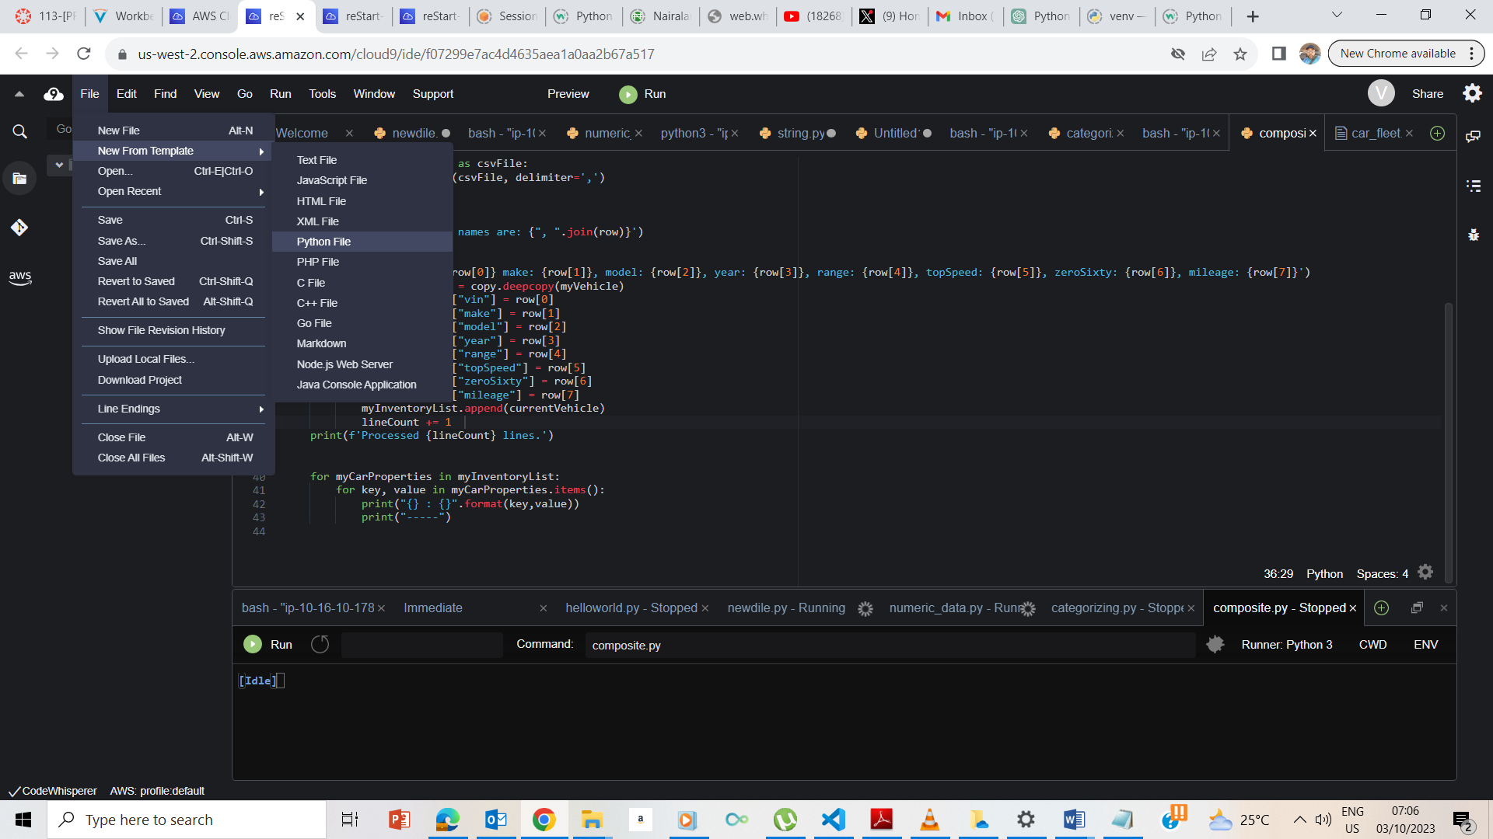

I clicked on the Open IDE icon and it took me to the IDE page and I now opened a new python file template.

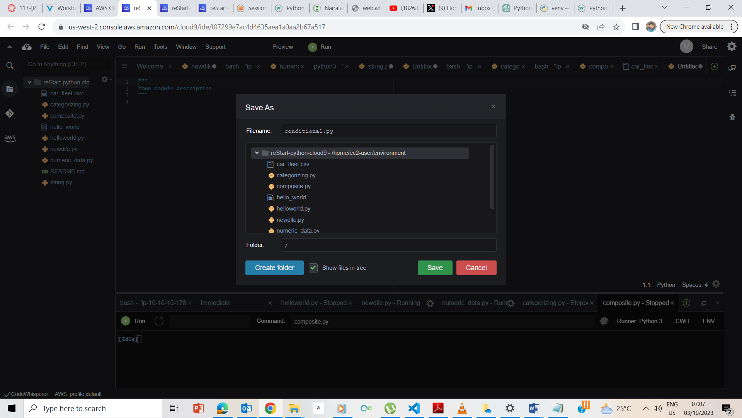

I saved the python file template

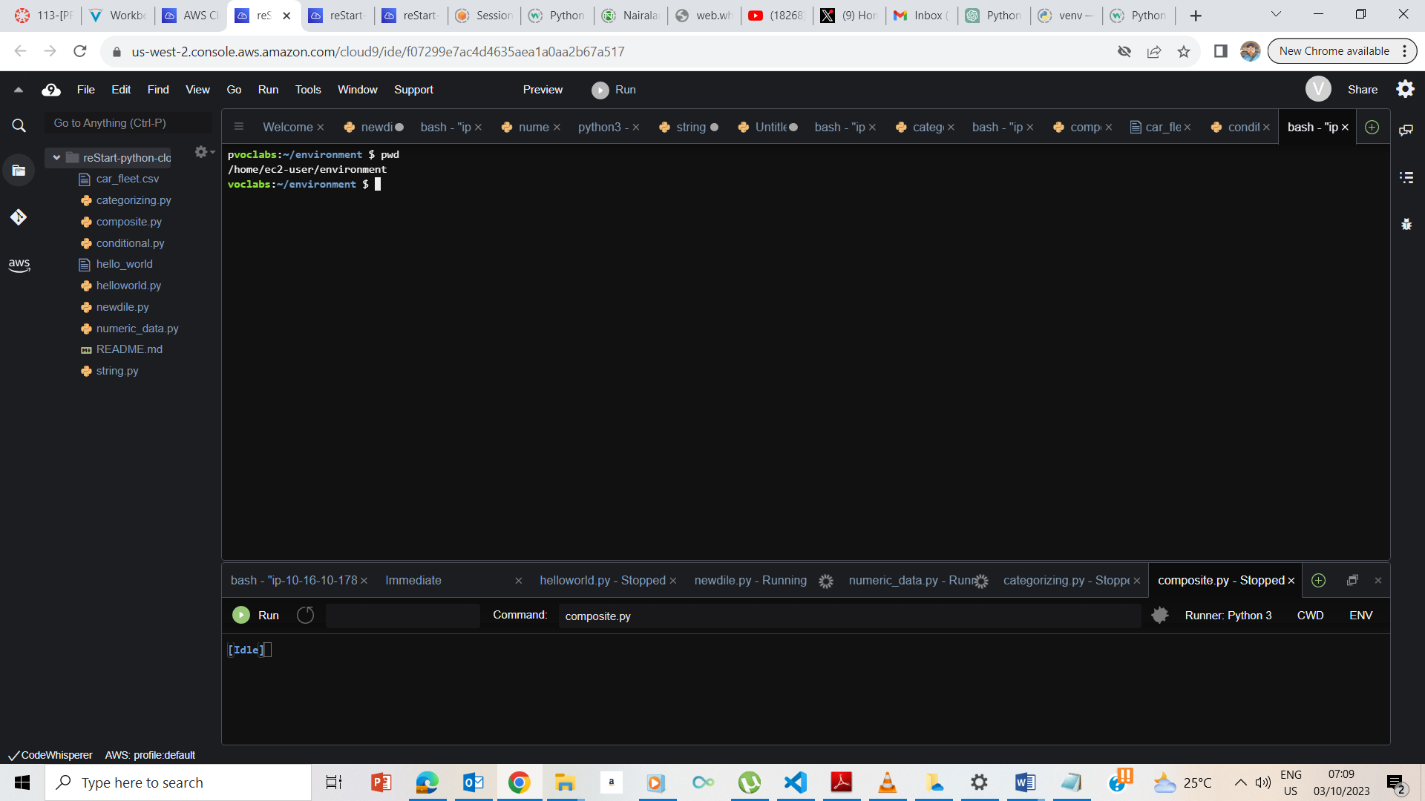

I opened a new terminal and entered pwd to confirm that I am on the ec2-user/environment

## **Exercise 1: Working with the if statement**

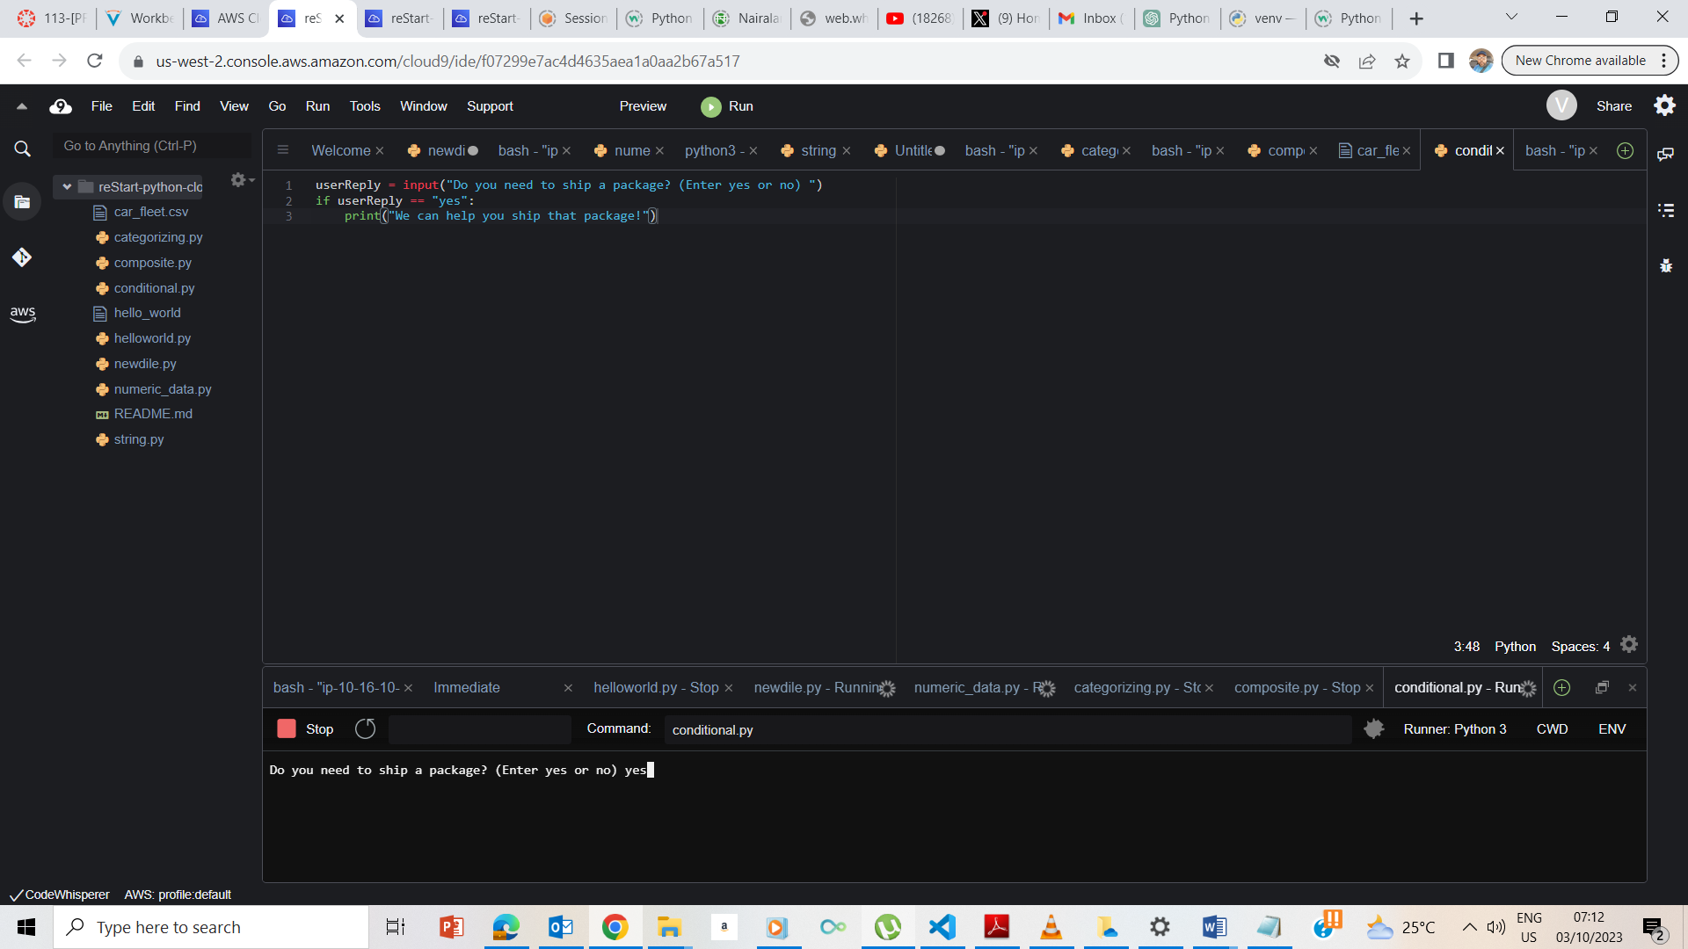

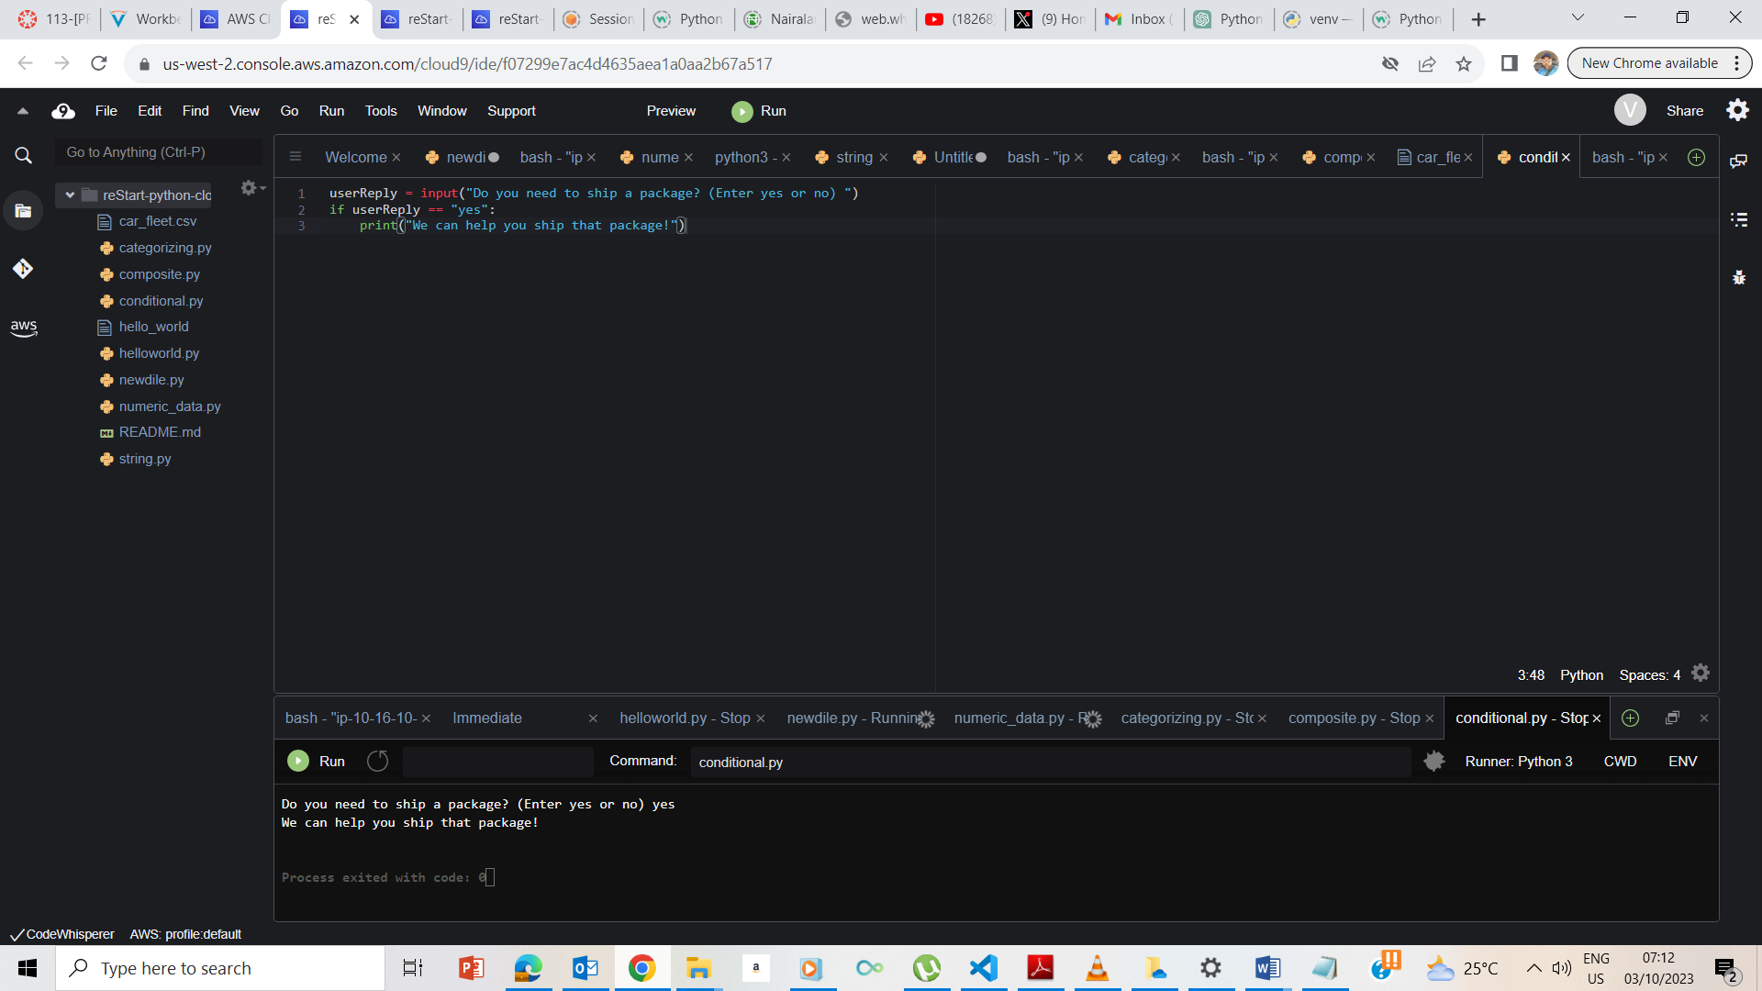

I entered yes to the input and it gave me the appropriate response of ‘we can help you ship the package.

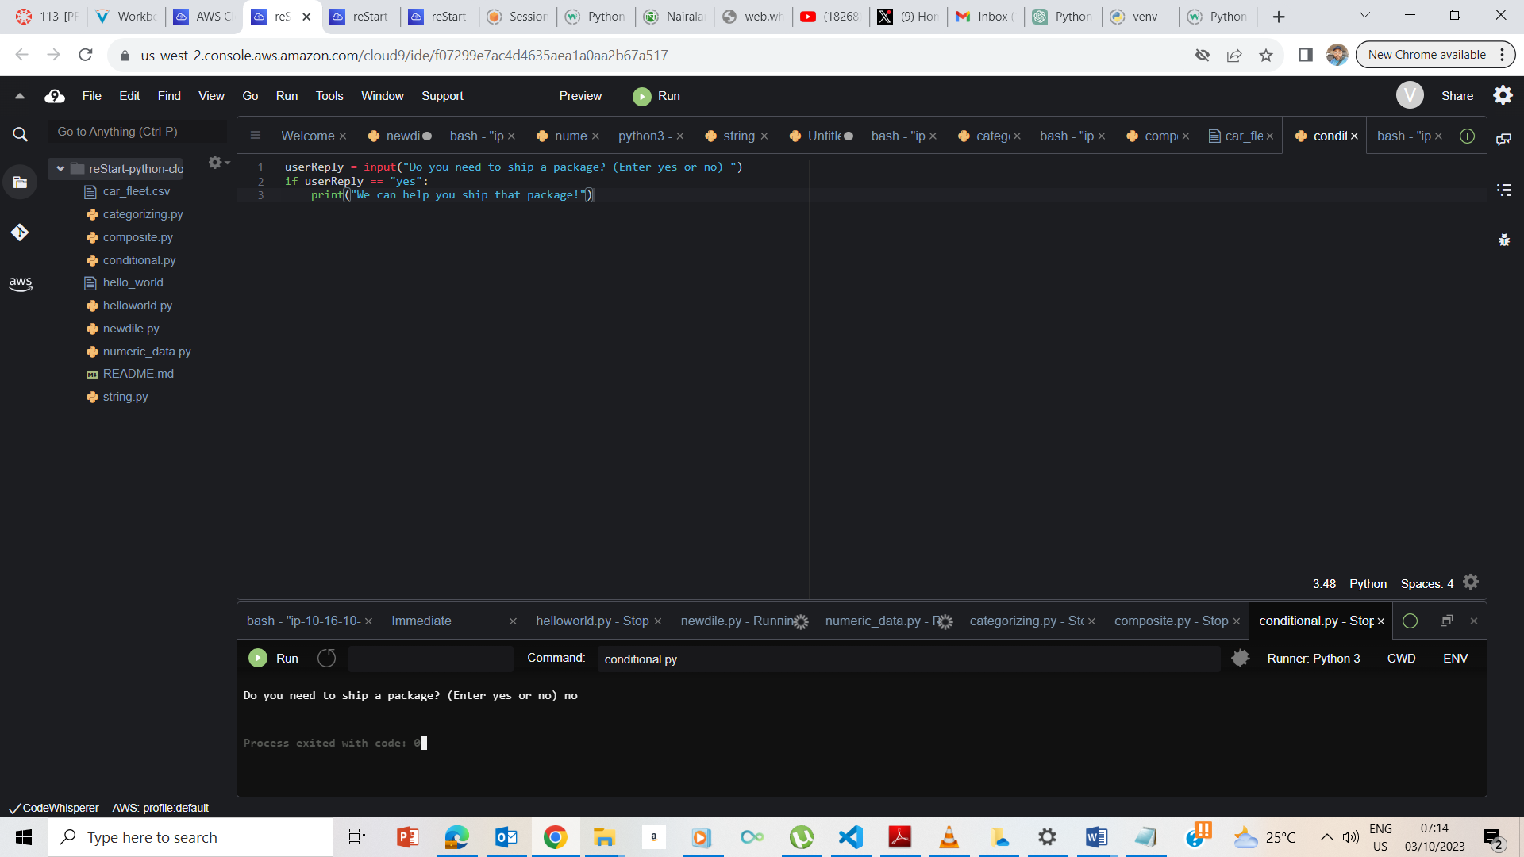

Upon entering no, there was no response as expected from the code.

## **Exercise 2: Working with the else statement**

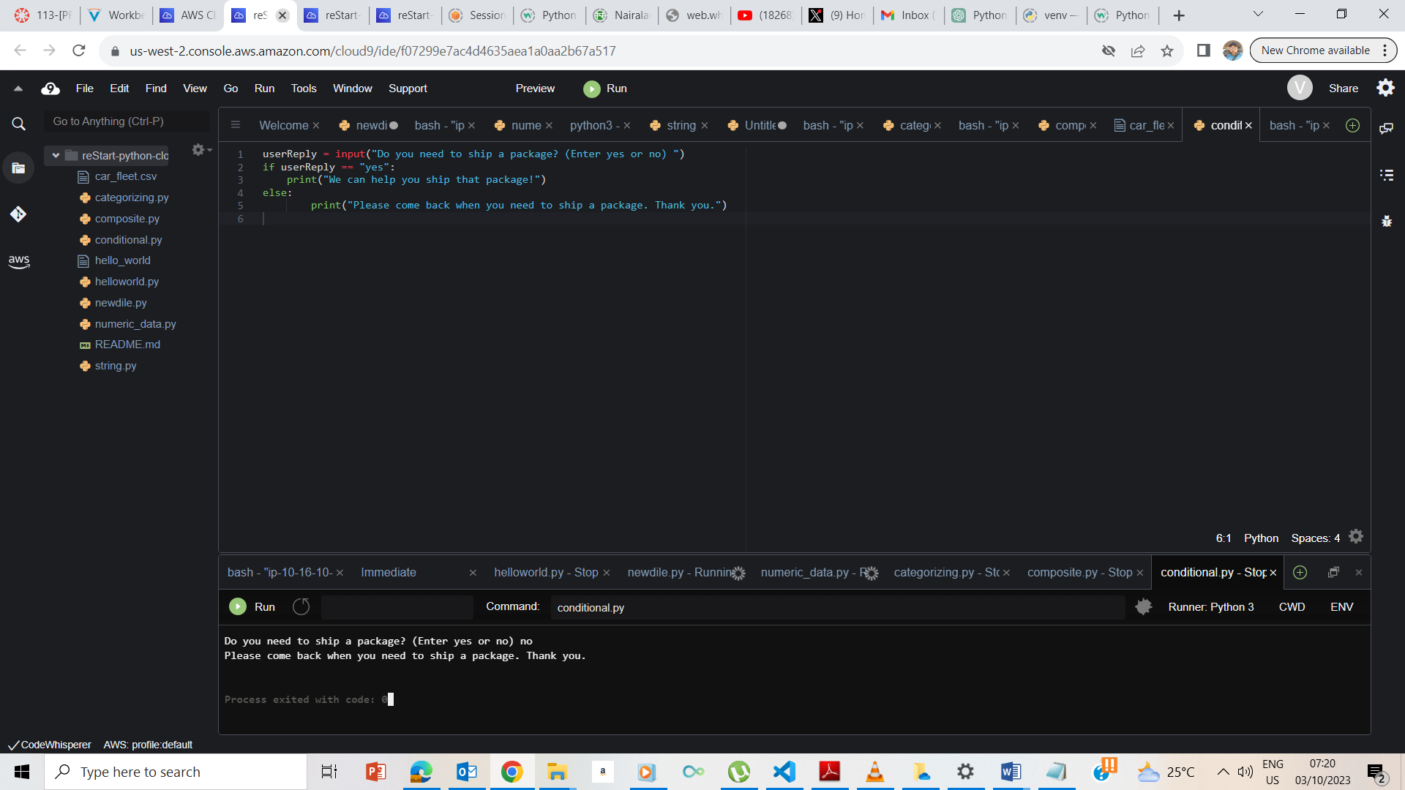

The else statement made it to print out another input upon entering no

## **Exercise 3: Working with the elif statement**

## 

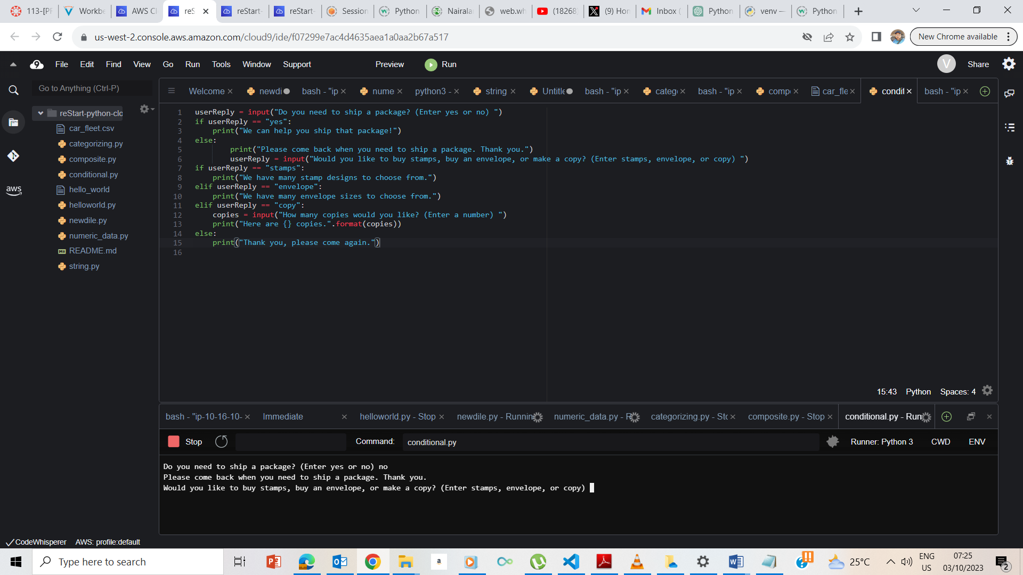

Command and response using elif .

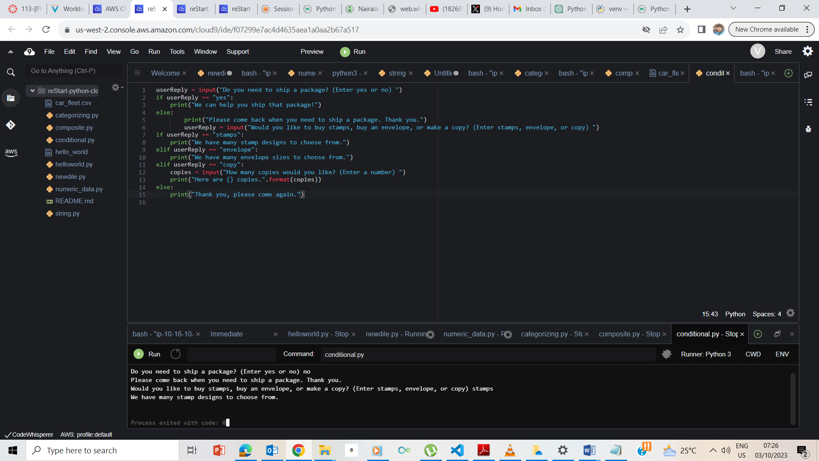

Response upon choosing stamps

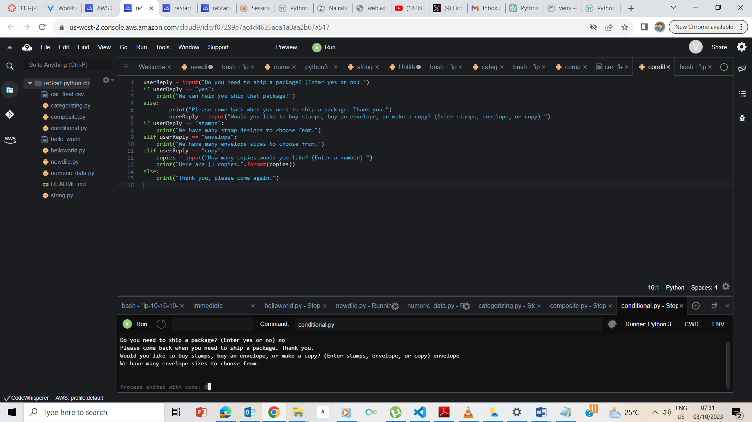

Response upon choosing envelope

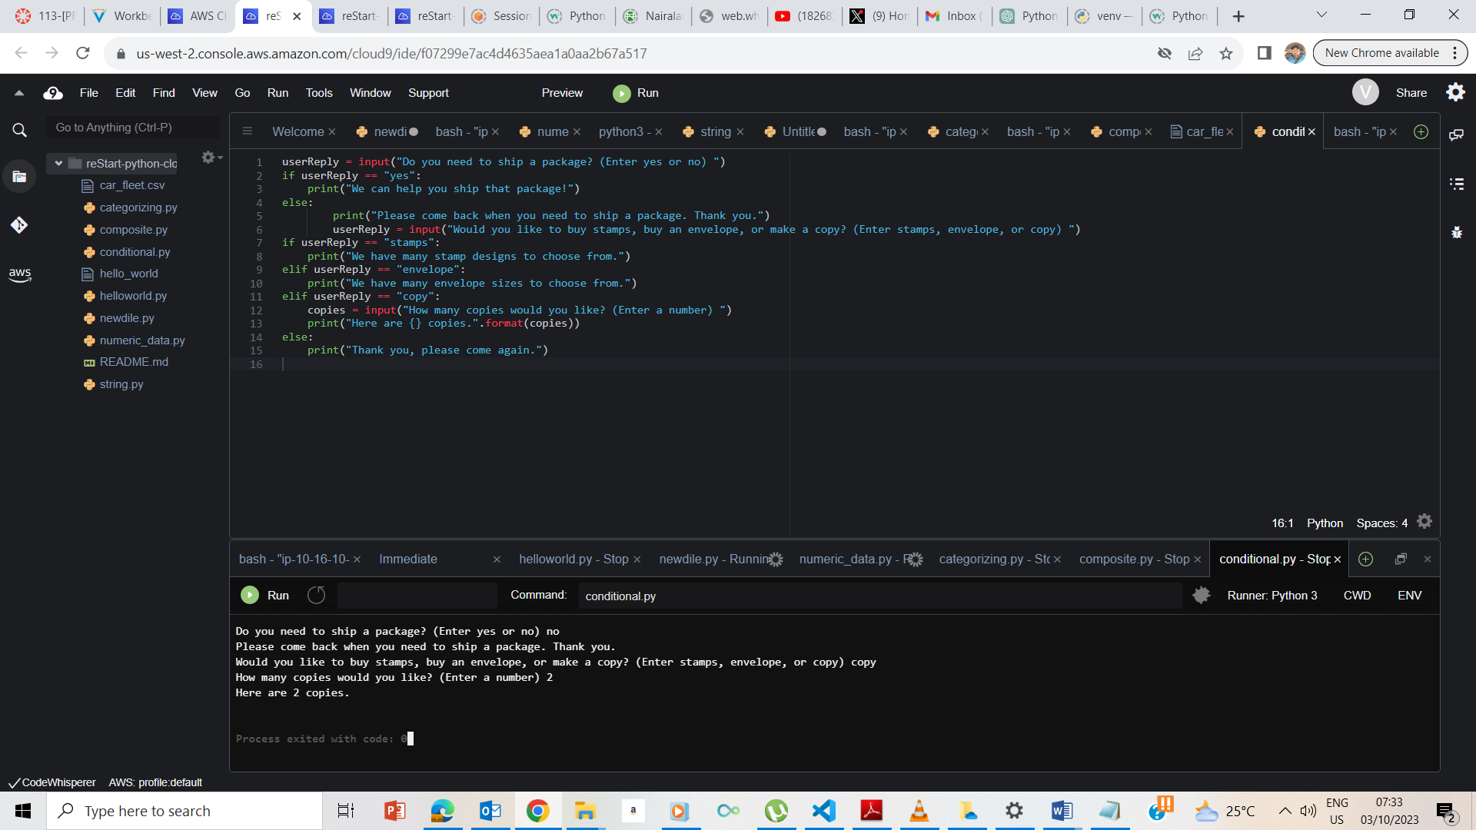

Response upon choosing copy

## **End Lab**

